Week-02-Operators and Expressions, Managing Input and Output Operation

Week-02-01-Practice Session-Coding

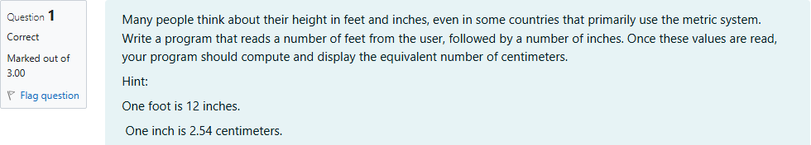

Source Code

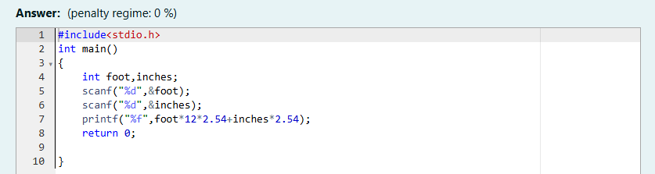

Result

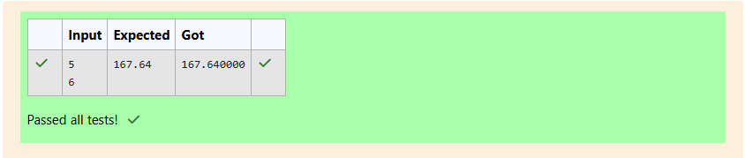

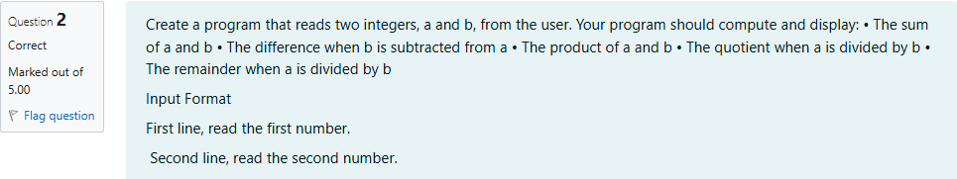

Source Code

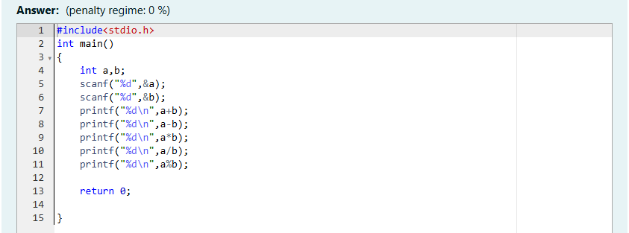

Result

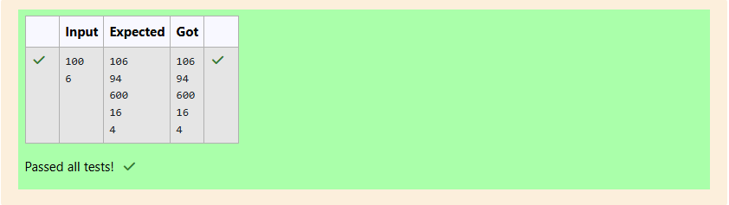

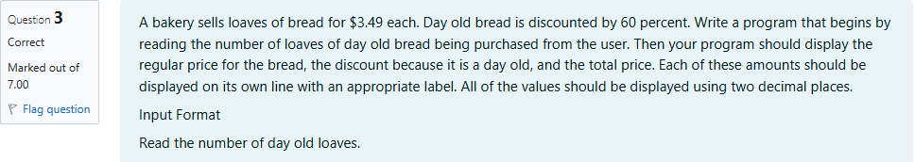

Source Code

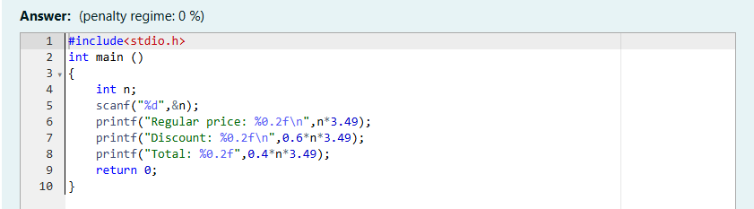

Result

